**Contact:**

Christie Kozak | Leary PR | [christie@learypr.com](mailto:christie@learypr.com) | 978-502-5747

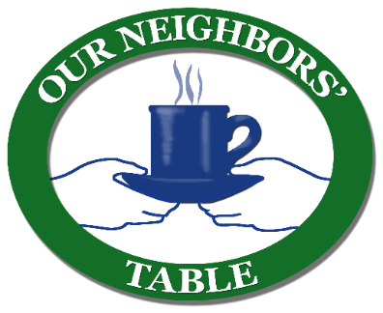

**Michael’s Harborside Hosts**

**Holiday Food Donation Drive for Our Neighbors’ Table**

NEWBURYPORT, MASSACHUSETTS (December 2024) – This holiday season, Newburyport Development and Michael’s Harborside are hosting a food donation drive to benefit Our Neighbors’ Table. Our Neighbors’ Table is a local nonprofit organization committed to building regional food security through food distribution, coordination, and community mobilization in the lower Merrimack Valley. With one in sixteen families experiencing food insecurity in the area, Our Neighbors’ Table provides unique grocery programs operated in an open market shopping model providing each guest with variety, privacy and dignity.

Now through December 30, 2024, items can be dropped off in the marked bins at Michael’s Harborside. Items of need include gluten-free food, healthy snacks, canned meals (stews, spaghetti & meatballs, chili, soups with meat), canned fruit, and juice boxes (no sugar added please). Personal care items needed include shampoo & soap, toothpaste & toothbrushes, deodorant, razors, feminine products & incontinence supplies.

"This holiday season we will be helping between 1,300 and 1,500 households keep their tables full. Our Neighbors' Table relies on community support to meet that need, and we are grateful to be surrounded by people willing to do their part to give back to their neighbors," explains Leanne Cavallaro, Community Engagement Coordinator. For more information, visit [OurNeighborsTable.org](http://ourneighborstable.org/).

“Michael’s Harborside is pleased to partner with Our Neighbors’ Table to fight food insecurity in our community,” says Rebekah Macchia, Director of Marketing for Newburyport Development. For more information, visit [NewburyportShops.com](https://www.newburyportshops.com/events/).

**Newburyport Development**

Newburyport Development, a New England Development Company, is located in the heart of downtown Newburyport, Massachusetts, where you’ll find historic neighborhoods and cobblestone streets alongside contemporary restaurants, a shopper’s paradise, and modern galleries. As one of Newburyport’s leading property owners and property managers, Newburyport Development owns more than 50 prime retail/office locations and residential units throughout downtown Newburyport, plus Newburyport Marinas, and Michael’s Harborside restaurant. Newburyport shops include Native Sun, Lively Kids, Best of British, Talbots, M.K. Benatti Jewelers, SOAK & Shoreline and many more. Dining selections feature Michael’s Harborside, Tuscan Sea Grill & Bar, BRINE Oyster Bar, The Poynt, Port Vida Mexican Cantina, Oregano Pizzeria and Ristorante, The Angry Donut, and The Goat, among others. All are part of Newburyport’s vibrant waterside setting, which offers some of New England’s best fishing, boating, dining, and shopping. For more information, visit [NewburyportDev.com](http://newburyportdev.com/) and [NewburyportShops.com](http://www.newburyportshops.com/).