Contact:
Christie Kozak | Leary PR | christie@learypr.com | 978-502-5747

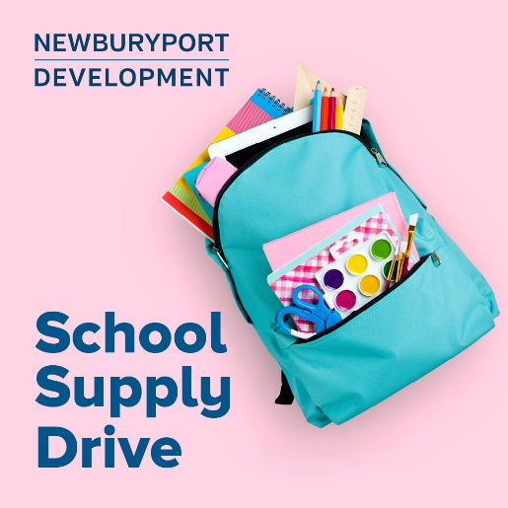

Newburyport Development Hosts School Supply Drive for
School on Wheels of Massachusetts

Donations accepted through August 25, 2024

NEWBURYPORT, MASSACHUSETTS (July 2024) – Newburyport Development is hosting a School Supply Drive for School on Wheels of Massachusetts now through August 25, 2024. Donations can be dropped off in the marked donation bin located at Michael’s Harborside.

Donations of need include new, unused backpacks, pencils & pencil sharpeners, blue or black inked pens, pencil pouches, glue sticks, plastic rulers, washable markers, composition notebooks and more. 100% of the proceeds will benefit School on Wheels of Massachusetts, whose mission is to support the academic, social, and emotional growth of students impacted by homelessness. Online donations to purchase school supplies can be made at SOWMA.org.

“School on Wheels of Massachusetts is committed to providing a quality backpack loaded with all the essentials needed for success in the classroom to the children we serve. This is a critical component of educational success and influences how a child feels entering school on that important first day,” explains Barbara Fox, Community Outreach Director for School on Wheels.

“Newburyport Development is pleased to continue our partnership with School on Wheels of Massachusetts to host this donation drive to help students start the school year off with the supplies they need,” says Rebekah Macchia, Director of Marketing for Newburyport Development. For more information, visit NewburyportShops.com.

About School on Wheels of Massachusetts
School on Wheels of Massachusetts (SOWMA) was founded in 2004 to bring one-on-one academic support to children struggling to stay on track and in school while experiencing homelessness. Since the start of the 2020/2021 academic year, SOWMA has distributed more than 6,000 new customized, grade-level backpacks to children and at-risk youth living in 38 Massachusetts communities. Trained volunteers provide one-on-one tutoring to 280 students at 18 program site locations from Boston to the South Coast. The Bridge Mentoring Program provides 57 high school and college-age students with a volunteer mentor, who shepherds students through high school and onto post-secondary plans, including college, vocational training, and jobs.
For more information, visit SOWMA.org.

Newburyport Development
Newburyport Development, a New England Development Company, is located in the heart of downtown Newburyport, Massachusetts, where you’ll find historic neighborhoods and cobblestone streets alongside contemporary restaurants, a shopper’s paradise, and modern galleries. As one of Newburyport’s leading property owners and property managers, Newburyport Development owns more than 50 prime retail/office locations and residential units throughout downtown Newburyport, plus Newburyport Marinas, and Michael’s Harborside restaurant. Newburyport shops include Native Sun, Lively Kids, Best of British, Talbots, M.K. Benatti Jewelers, SOAK & Shoreline and many more. Dining selections feature Michael’s Harborside, Tuscan Sea Grill & Bar, BRINE Oyster Bar, The Poynt, Port Vida Mexican Cantina, Oregano Pizzeria and Ristorante, The Angry Donut, and The Goat, among others. All are part of Newburyport’s vibrant waterside setting, which offers some of New England’s best fishing, boating, dining, and shopping. For more information, visit NewburyportDev.com and NewburyportShops.com.

