Contact: Christie Kozak | Leary PR | christie@learypr.com | 978-502-5747
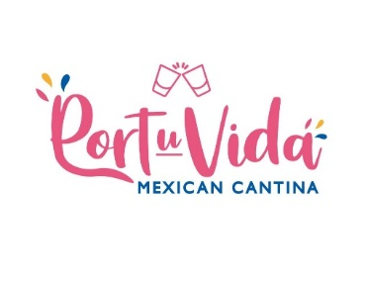
Port Vida Mexican Cantina Now Open

NEWBURYPORT, MASSACHUSETTS (April 2023) – Port Vida a Mexican Cantina is now open at 10 Center Street in downtown Newburyport. Port Vida is a new Mexican restaurant concept from Daniel Vargas, the owner of Casa Blanca Mexican Restaurant (Andover, MA) who brings over twenty years of experience as a restauranteur to the new eatery. Port u Vida translates to “For Your Life” and offers fresh, healthful, and innovative fare. The restaurant is the perfect place to gather friends and family to enjoy food, drinks, and music.

Daniel Vargas and his wife Elsa have created a menu that highlights traditional Mexican cuisine including Sopes, tacos, burritos, and fajitas alongside innovative menu additions such as Guajillo rub Grill T-Bone steak and House BBQ smoked pork ribs. In the warmer weather, Port Vida will feature a beautiful patio with outdoor seating and will host private events.

“The menu dishes come from our roots, our people, and our culinary traditions. Port Vida is an Authentic Mexican Cantina that offers a chic, downtown environment right here in Newburyport and we are glad to be part of this community,” says Daniel Vargas, co-owner of Port Vida.

“We are delighted to welcome Port Vida to Newburyport,” says Rebekah Macchia, Marketing Director for Newburyport Development. “Port Vida will present contemporary twists to the traditional Mexican Cantina focusing on the freshest of ingredients and innovative menu concepts,” she adds.

Newburyport Development
Newburyport Development, a New England Development Company, is located in the heart of downtown Newburyport, Massachusetts, where you’ll find historic neighborhoods and cobblestone streets alongside contemporary restaurants, a shopper’s paradise, and modern galleries. As one of Newburyport’s leading property owners and property managers, Newburyport Development owns more than 50 prime retail/office locations and residential units throughout downtown Newburyport, plus Newburyport Marinas, and Michael’s Harborside restaurant.

Newburyport shops include Native Sun, Lively Kids, Best of British, Talbots, M.K. Benatti Jewelers, SOAK & Shoreline and many more. Dining selections feature Michael’s Harborside, Tuscan Sea Grill & Bar, BRINE Oyster Bar, The Poynt, Oregano Pizzeria and Ristorante, The Angry Donut, and The Goat (coming soon), among others. All are part of Newburyport’s vibrant waterside setting, which offers some of New England’s best fishing, boating, dining, and shopping. For more information, visit NewburyportDev.com and NewburyportShops.com.

