Contact: Christie Kozak | Leary PR | christie@learypr.com | 978-502-5747

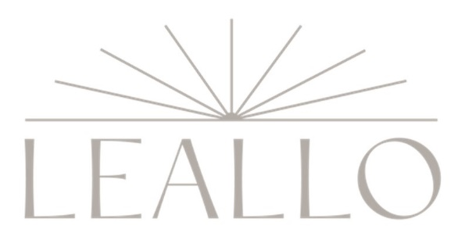

LEALLO Now Open at 15 State Street, Newburyport, MA

NEWBURYPORT, MASSACHUSETTS (May 2023) – Lifestyle brand LEALLO is now open at 15 State Street in downtown Newburyport. LEALLO features an extensive selection of beautifully constructed, luxuriously soft wardrobe staples for women including tees, sweatshirts, sweatpants, shorts, jackets, jumpsuits, and dresses. LEALLO was founded in 2015 by lifelong fashion industry professional and Hamptons resident Meg Chiarello. The downtown Newburyport store will be the retailer’s first in Massachusetts with longtime Newburyport resident Kara Chiarello at the helm of the boutique.

“Over many years visiting my family, I simply fell in love with Newburyport and its welcoming residents, natural beauty, and authentic downtown vibe. The timing feels right to open our first LEALLO in this amazing town and we are thrilled to be a part of its vibrant retail community,” says Meg Chiarello, founder of LEALLO.

With an emphasis on keeping a low carbon footprint, LEALLO offers eco-conscious packaging, low water consumption dyes, natural fabrics and quality construction that withstand the test of time. LEALLO clothing is made from clean pre-shrunk Peruvian Pima cotton and high-quality cashmere, constructed in certified fair-trade factories, and designed to wash-and-wear beautifully year after year. The brand makes clothing for daughters, mothers, and grandmothers—women who love nature, art, and movement and who strive daily to feel free, comfortable, and authentic.

“LEALLO is the perfect addition to Newburyport’s shopping offerings,” says Rebekah Macchia, Marketing Director for Newburyport Development. “Shoppers will love the timeless styling and effortless comfort of LEALLO fashions,” she adds.

Newburyport Development
Newburyport Development, a New England Development Company, is located in the heart of downtown Newburyport, Massachusetts, where you’ll find historic neighborhoods and cobblestone streets alongside contemporary restaurants, a shopper’s paradise, and modern galleries. As one of Newburyport’s leading property owners and property managers, Newburyport Development owns more than 50 prime retail/office locations and residential units throughout downtown Newburyport, plus Newburyport Marinas, and Michael’s Harborside restaurant. Newburyport shops include Native Sun, Lively Kids, Best of British, Talbots, M.K. Benatti Jewelers, SOAK & Shoreline and many more. Dining selections feature Michael’s Harborside, Tuscan Sea Grill & Bar, BRINE Oyster Bar, The Poynt, Oregano Pizzeria and Ristorante, The Angry Donut, and The Goat (coming soon), among others. All are part of Newburyport’s vibrant waterside setting, which offers some of New England’s best fishing, boating, dining, and shopping. For more information, visit NewburyportDev.com and NewburyportShops.com.

