Contact:
Christie Kozak | Leary PR | christie@learypr.com | 978-502-5747

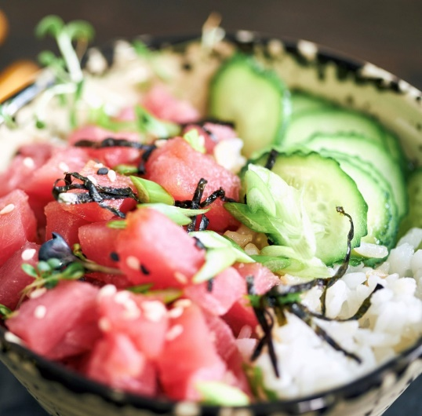
Michael’s Harborside Tuna Poke

Newburyport Restaurant Week March 12-26, 2023
Exciting Lunch and Dinner Specials

NEWBURYPORT, MASSACHUSETTS (March 2023) – Diners can mark their calendars for Newburyport Restaurant Week, March 12 through March 26, 2023. Participating eateries will offer price fixe lunch and dinner multi-course specials sure to please every palate. For a full list of participating restaurants visit NewburyportChamber.org.

“We are delighted that so many of our local restaurants are participating in Newburyport Restaurant Week,” says Rebekah Macchia, Marketing Director for Newburyport Development. “It’s a wonderful opportunity to visit our eateries and enjoy their many delicious offerings,” she adds.

Highlights of Newburyport Restaurant Week include:

Brine Oyster Bar
17 State Street
Dinner Menu, $42 per person (with wine pairing, add $27).
4:00 p.m.to 10:00 p.m. Excludes Friday and Saturday.
Enjoy first course selections of Vichyssoise or Farm Greens, entrée choice of Monkfish, Chicken Breast, or Risotto; Caramel Flan or Flourless Chocolate Torte for dessert. For more information, visit www.brineoyster.com.

Mandarava
46 Inn Street
Special Restaurant Week to-go menu features Vegan Ramen, Tropical Fruit Mousse and Dan’s Whimsical Punch. For more information, visit www.mandarava.shop.

Michael’s Harborside
1 Tournament Wharf
Lunch Menu, $27 per person; Dinner Menu, $32 per person.
From starters select Crispy Calamari, Fried Pickles, or Tuna Poke. From Entrees choose from New England Baked Haddock, Shrimp Scampi, Fish ‘n Chips plate or Steak Tip Caesar Salad. Choose Strawberry Shortcake or a Brownie Sundae for Dessert. For more information, visit michaelsharborside.com.

The Poynt
31 Water Street
Dinner Menu, $42 per person.
Small plate choice of Peach & Hazelnut or Tuna Salad. Entrée selection of Seared Scallops or
Bife à Rolê. Dessert choose Banoffee Pie or Vanilla Bean Cheesecake. For more information, visit poyntnewburyport.com.

Tuscan Sea Grill
38R Merrimac Street
Three course menu $36 per person. Menu features Beet Salad, Lobster Arancini and Roasted Statler Chicken. Excludes Friday & Saturday. For more information, visit, tuscanseagrillbar.com.

Newburyport Development
Newburyport Development, a New England Development Company, is located in the heart of downtown Newburyport, Massachusetts, where you’ll find historic neighborhoods and cobblestone streets alongside contemporary restaurants, a shopper’s paradise, and modern galleries. As one of Newburyport’s leading property owners and property managers, Newburyport Development owns more than 50 prime retail/office locations and residential units throughout downtown Newburyport, plus Newburyport Marinas, and Michael’s Harborside restaurant.

Newburyport shops include Native Sun, Lively Kids, Best of British, Talbots, M.K. Benatti Jewelers, SOAK & Shoreline and many more. Dining selections feature Michael’s Harborside, Tuscan Sea Grill & Bar, BRINE Oyster Bar, The Poynt, Oregano Pizzeria and Ristorante, The Angry Donut, and The Goat (coming soon), among others. All are part of Newburyport’s vibrant waterside setting, which offers some of New England’s best fishing, boating, dining, and shopping. For more information, visit NewburyportDev.com and NewburyportShops.com.

# # #

