Contact:
Christie Kozak | Leary PR | christie@learypr.com | 978-502-5747

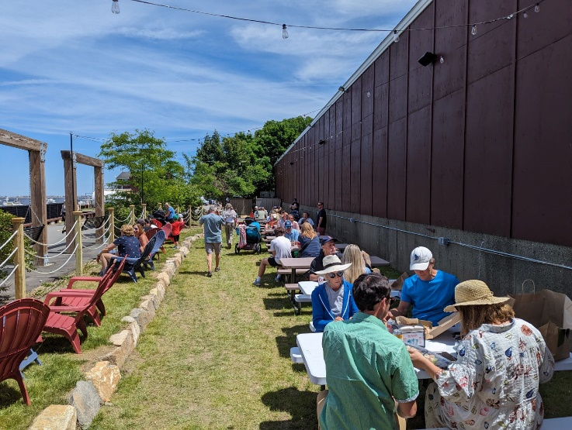

Newburyport Development Announces
Newburyport Brewing Beer Garden at Oldies

Open weekends through early September 2024

NEWBURYPORT, MASSACHUSETTS (June 2024) – Newburyport Development has announced the opening of the Newburyport Brewing Beer Garden at Oldies, a series of pop-up summer weekend beer gardens located on the lawn at 27 Rear Water Street behind Oldies Vintage Marketplace in downtown Newburyport.

Modeled after some of the most popular outdoor riverside beer gardens in Germany and Austria, the European-style, family-friendly Beer Garden at Oldies will be a community gathering spot for locals and visitors alike. Located adjacent to the Newburyport rail trail, the pop-up beer garden at Oldies will feature fresh craft beer and hard seltzer, community picnic tables, Adirondack chairs, local musicians including a singer-songwriter and fiddle player, cornhole and other lawn games.

The Beer Garden at Oldies will be open from mid-June through early-September with planned rain dates.
The garden is free and open to the public and will operate on select Fridays, Saturdays, and Sundays from 12:00 p.m. to 9:00 p.m. daily. Newburyport Brewing Co. will provide a selection of beverages for purchase including canned beers featuring its award-winning Plum Island Belgian White and Green Head IPA ales, hard seltzers, non-alcoholic brews, and soft drinks. The Poynt restaurant will offer a special food delivery menu with assigned runners bringing ordered meals directly to the beer garden.

“We are thrilled to be able to team with Newburyport Development and The Poynt to bring a true summer beer garden experience to downtown Newburyport this summer,” says Bill Fisher, co-owner of Newburyport Brewing. “The Beer Garden at Oldies will be a wonderful place for families and friends to gather to enjoy the waterfront while playing games, listening to music, sipping on local favorite brews and enjoying bites from The Poynt.”

About the Newburyport Brewing Company
Newburyport Brewing is a privately held craft brewery dedicated to brewing the highest quality craft beer products for local and regional consumers. Co-founded in 2012 by two local Newburyport entrepreneurs, musicians, and home brewers - Chris Webb and Bill Fisher - the company captures the essence of Newburyport's quaint seaside character across a line of great tasting handcrafted beers and seltzers. The brewery uses premium quality natural ingredients in its products: Green Head IPA, Plum Island Belgian White, 110 Ale, Overboard New England IPA, Melt Away IPA, Maritime Lager, and 1635 Series small batch beers. On the Web at NBPTBrewing.com, on Facebook at NewburyportBrewingCo or follow @NBPTbrewing.

Newburyport Development
Newburyport Development, a New England Development Company, is located in the heart of downtown Newburyport, Massachusetts, where you’ll find historic neighborhoods and cobblestone streets alongside contemporary restaurants, a shopper’s paradise, and modern galleries. As one of Newburyport’s leading property owners and property managers, Newburyport Development owns more than 50 prime retail/office locations and residential units throughout downtown Newburyport, plus Newburyport Marinas, and Michael’s Harborside restaurant. Newburyport shops include Native Sun, Lively Kids, Best of British, Talbots, M.K. Benatti Jewelers, SOAK & Shoreline and many more. Dining selections feature Michael’s Harborside, Tuscan Sea Grill & Bar, BRINE Oyster Bar, The Poynt, Port Vida Mexican Cantina, Oregano Pizzeria and Ristorante, The Angry Donut, and The Goat, among others. All are part of Newburyport’s vibrant waterside setting, which offers some of New England’s best fishing, boating, dining, and shopping. For more information, visit NewburyportDev.com and NewburyportShops.com.

# # #

